- What is internet?
A world-wide network of computer networks. At the lowest level, since 1982, all connections use TCP/IP. TCP/IP hides the differences among devices connected to the Internet.

- Internet Protocol (IP) Addresses:
- Every node has a unique numeric address
- Form: 32-bit binary number
- New standard, IPv6, has 128 bits
- Organizations are assigned groups of IPs for their computers

Protocol is a standard set of rules that allow electronic devices to communicate with each other.

Domain Name:
A domain is a name that identifies IP addresses on the internet like w3schools.com. Without a domain name, anyone who wanted to visit your website would have to enter the full IP address. But the problem is that an IP address is difficult for people to memorize or to include on advertising materials.

Domain Name System (DNS): Convert fully qualified domain names to IPs address.

- The World-Wide Web
The World-Wide Web (WWW), commonly known simply as the Web, is a system of interconnected documents and other resources, accessible over the Internet. It was invented by Sir Tim Berners-Lee in 1989 while working at CERN (European Organization for Nuclear Research) and has revolutionized how information is shared and accessed globally.
Key Concepts:
- Hypertext: The Web is built on hypertext, which is a system that allows users to click on links (called hyperlinks) to navigate between different documents or web pages.

- Web Pages: The basic units of the Web are web pages, which are documents typically written in HTML (Hypertext Markup Language). These pages can include text, images, videos, and other multimedia elements.

- Web Browsers: A web browser (such as Google Chrome, Firefox, or Safari) is software used to access the Web. It requests information from web servers and displays it to the user in a readable format.

- URLs: Each web page is identified by a URL (Uniform Resource Locator), which serves as its address on the web. For example, `https://www.example.com` is a URL.

- HTTP/HTTPS: The Hypertext Transfer Protocol (HTTP) is the foundational communication protocol used for transmitting data between a web browser and a web server. HTTPS is a more secure version of HTTP that encrypts the data exchange to protect sensitive information.

- Web Servers: Web servers are computers that host websites and respond to requests from web browsers. When you type a URL in your browser, it sends a request to a web server, which delivers the requested web page back to your browser.

Evolution and Importance:
- The Web started as a means for sharing scientific research and has since evolved into a vast information and communication platform used for entertainment, social networking, business, education, and much more.
- It is distinct from the Internet, which is the global network of interconnected computers. The Web is a service that runs on the Internet, but the Internet also supports other services like email, file transfer, and online gaming.
The World-Wide Web has transformed the way we communicate, share information, and conduct daily activities, making it one of the most impactful technologies in modern history.

World Wide Web Communication
The World Wide Web is about communication between web clients and web servers.

Client:
- The client is typically a device or software that makes requests to a server for specific resources or services. This could be a web browser on your laptop, a mobile app, or any other application.
- Clients initiate communication and typically do not share their own resources; instead, they request information or services from the server.
- Examples of clients: Web browsers (Chrome, Firefox), mobile apps, email clients, etc.
Server:
- The server is a machine or program that provides resources or services to clients. It waits for requests from clients, processes them, and returns the requested data or functionality.
- Servers can manage multiple clients simultaneously and are responsible for handling tasks like data storage, processing, and security.
- Examples of servers: Web servers, database servers, email servers, file servers, etc.

How Client-Server Architecture Works:

Communication between client computers and web servers is done by sending Requests and receiving Responses:

- Client Request: The client (such as a web browser) sends a request to the server over a network (usually the Internet or a local network).
- Server Response: The server processes the request and sends back the appropriate response. This response could be a web page, a file, data from a database, or an acknowledgment of a completed action.
- Interaction: Clients and servers communicate via a protocol such as HTTP/HTTPS, FTP, or SMTP.
For example, when you visit a website:
- The web browser (client) sends an HTTP request to the web server, asking for the content of a webpage.
- The web server receives the request, processes it, and sends back the HTML, CSS, and other resources (like images and videos) needed to display the webpage.

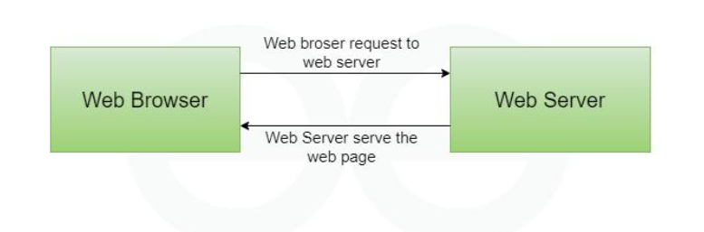
Web Security Issues: There are many kinds of security problems with the Internet and the Web. One fundamental problem is getting data between a browser and a server without it being intercepted or corrupted in the process. Security issues for a communication between a browser and a server:
- Privacy: credit card to be stolen in the way to the server.
- Integrity: credit card to be modified.
- Authentication: it must be possible for both the purchaser and seller to be certain of each other identity.
- Nonrepudiation: it must be possible to prove legally that the message was sent and received.
- Destruction of data on computers connected to the Internet
- Viruses and worms

- HTML and Other Web Technologies:

HTML (Hypertext Markup Language) is the standard language used to create and design the structure of web pages on the World Wide Web. It describes the elements of a web page using a system of tags and attributes, which browsers interpret and render to display the content.
CSS (Cascading Style Sheets): Works with HTML to style the visual presentation of web pages (e.g., fonts, colors, layouts).
JavaScript: Adds interactivity and dynamic content to web pages (e.g., forms that validate input before submission, animations, etc.).
